**Part 8 – Solving Rational Equations**

**Example.** Solve

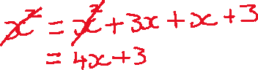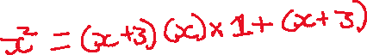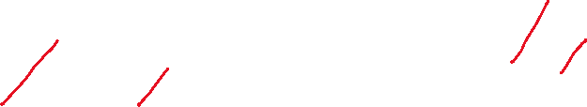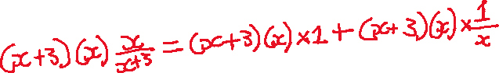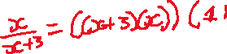

**Example.** Solve

